Lab Exercise 18- Scanning IaC Templates for Vulnerabilities

Objective

- Learn how to scan Infrastructure as Code (IaC) templates for security vulnerabilities.
- Use open-source IaC security tools to detect misconfigurations.

- Understand common risks such as public access, unencrypted resources, and insecure network rules.

Prerequisites

- A Linux/Windows/Mac machine with:

  - Terraform installed (for sample IaC)

  - Checkov (pip install checkov) or tfsec (brew install tfsec or binary download)
- Git installed (optional, for version control of IaC templates)

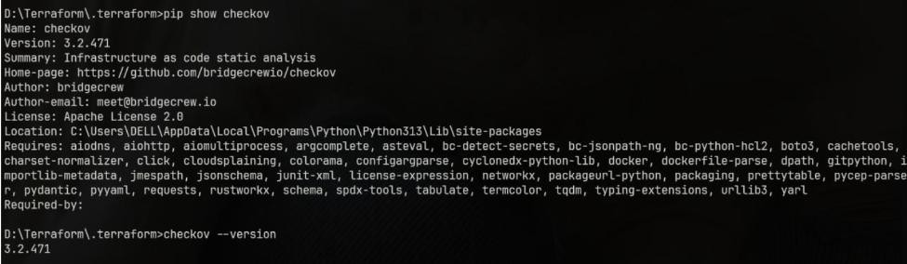
•

Step 1: Create an Insecure IaC Template

Create a file named main.tf with the following Terraform code:

provider "aws" { region = "us-east-1"
}

resource "aws_s3_bucket" "insecure_bucket" { bucket = "my-insecure-bucket-lab"
acl = "public-read"
}

resource "aws_security_group" "insecure_sg" {
name
= "insecure-sg"
description = "Allow all inbound traffic" ingress {
from_port = 0

to_port = 65535 protocol = "tcp"
cidr_blocks = ["0.0.0.0/0"]

}
}

Step 2: Scan the Template with Checkov

Run Checkov on the current directory:

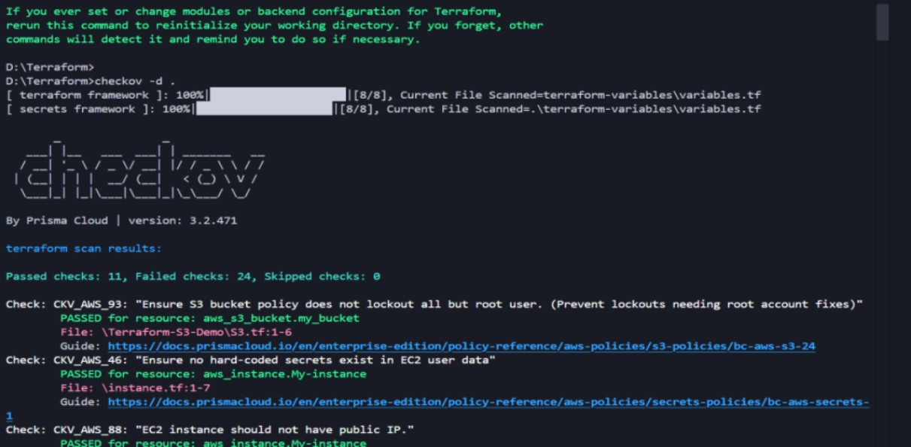
checkov -d .

Expected Findings:

- Public S3 bucket access (public-read)

- Security group open to all inbound traffic

Expected Findings:

- Warns about S3 bucket without encryption

- Flags open Security Group rules

Step 4: Review the Report

Example output (Checkov):

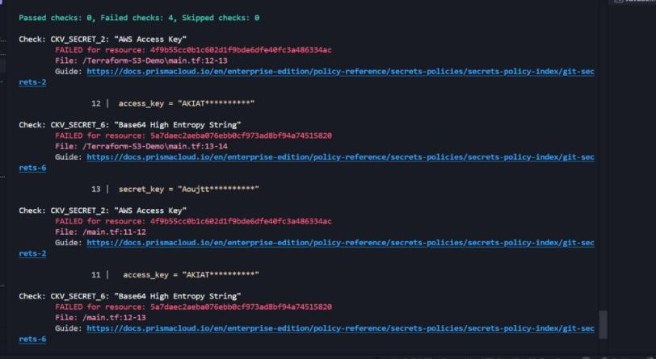
Check: CKV_AWS_20: "S3 Bucket allows public read access" FAILED for resource: aws_s3_bucket.insecure_bucket
Check: CKV_AWS_260: "Security group allows ingress from 0.0.0.0/0" FAILED for resource: aws_security_group.insecure_sg

Step 5: Apply Fixes (Optional)

Modify the IaC template to:

- Set S3 bucket ACL to private

- Enable encryption (AES256)

- Restrict Security Group to specific IP ranges

Step 6: Rescan the Template

Run the scan again:

checkov -d .
Now the findings should be resolved or reduced.

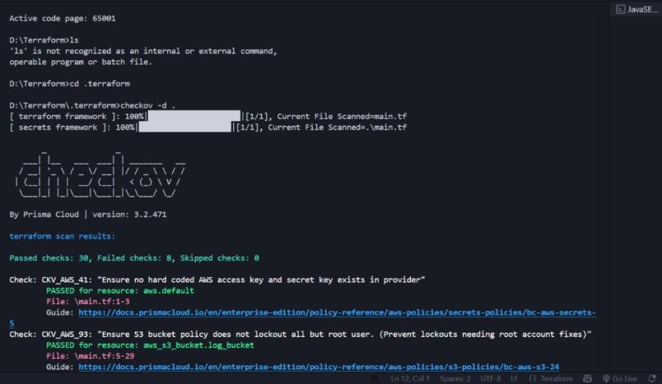

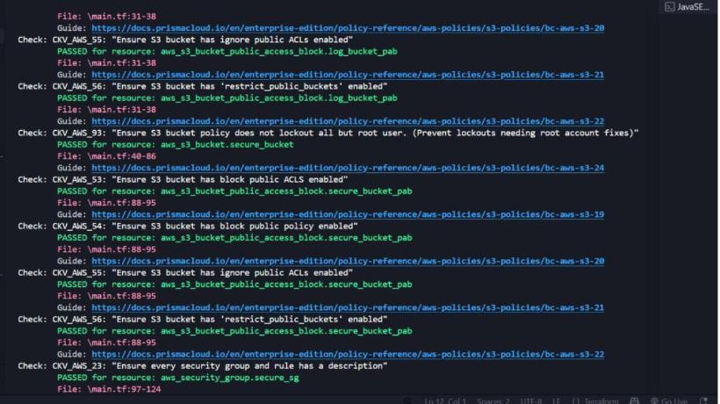

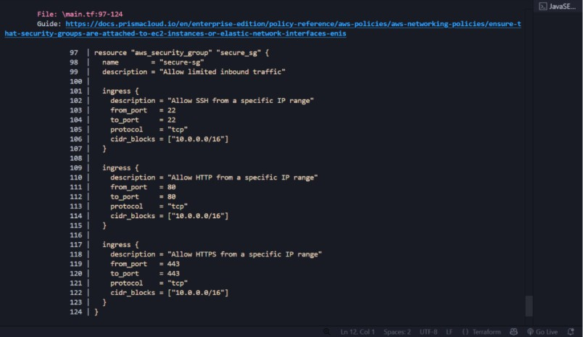

Step 7: Document Findings

Create a simple findings log:

